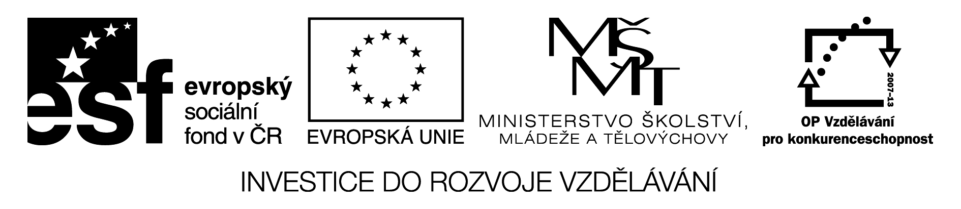
Present simple or continuous?

1. Doplň now nebo every day
a) Peter is buying a new car ______________ .
b) Alice is writing homework ______________ .
c) Alice writes homework _________________ .
d) Nick and Dick play football _____________________ .
e) Nick and Dick are playing football _________________ .

2.Podtrhni správný tvar slovesa:
a) Is he having/ Has he got a dog?
b) We go / are going to school every day.
c) What are you doing / do you do now?
d) Where is / are Lucy?

3. Napiš správnou formu sloves v závorce.
Mr. Novák usually ___________________ (get up) at 7 o´clock, but today he ____________________________ (get up) at 6 o´clock. At the moment he _________________________ (wear) blue jeans and black T-shirt. He usually ___________________(go) by bus but today he _____________________(go) by train.

4. Cvičení 3. přelož do češtiny.

KLÍČ:
Present simple or continuous?

1. Doplň now nebo every day
a) Peter is buying a new car _______now_______ .
b) Alice is writing homework _________now_____ .
c) Alice writes homework _______________every day__ .
d) Nick and Dick play football ___________________every day__ .
e) Nick and Dick are playing football ____________now_____ .

2.Podtrhni správný tvar slovesa:
a) Is he having/ Has he got a dog?
b) We go / are going to school every day.
c) What are you doing / do you do now?
d) Where is / are Lucy?

3. Napiš správnou formu sloves v závorce.
Mr. Novák usually ____gets up_______ (get up) at 7 o´clock, but today he is getting up_____ (get up) at 6 o´clock. At the moment he __is wearing__ (wear) blue jeans and black T-shirt. He usually ___goes_____(go) by bus but today he __is going___(go) by train.

4. Cvičení 3. přelož do češtiny.
Pan Novák obvykle vstává v 7 hodin, ale dneska vstává v 6 hodin. Právě si obléká modré džíny a černé tričko. On obvykle jezdí autobusem, ale dneska jede vlakem.

